Developing Early College Occupational Programs of Study

Quick Reference Guide

Under 18 students may have access to earned college by successfully completing work-based certificates, nationally recognized exams, and/or college courses during or outside of the college day. Earned credit by work-based or nationally recognized exam should have prior approval by the college district. For example, a student that earns a 5 or 4 on the Advanced Placement English Language and Composition exam may earn college credit for English Composition 1. Whereas a student that successfully completes the CompTIA+ exam may earn college credit for Computer Hardware and Operating System Configuration and Support. High School students may earn credit for college courses that they complete during our outside of the high school day and apply it to high school graduation requirements if the course is above high school level (100 level and above) and applies to a community college certificate or degree. Physical education courses are not available for dual enrollment purposes.

The process below may be used to establish early college programs of study for high school students to make progress towards completing occupational certificates and degrees.

# Step 1: Identify High Value Occupational Programs

The Local Education Agency (LEA) uses workforce data to identify career and technical (CTE) programs to offer on a high school campus. Approved CTE programs are listed on the Arizona Department of Education (ADE) website: <https://www.azed.gov/cte/programs> 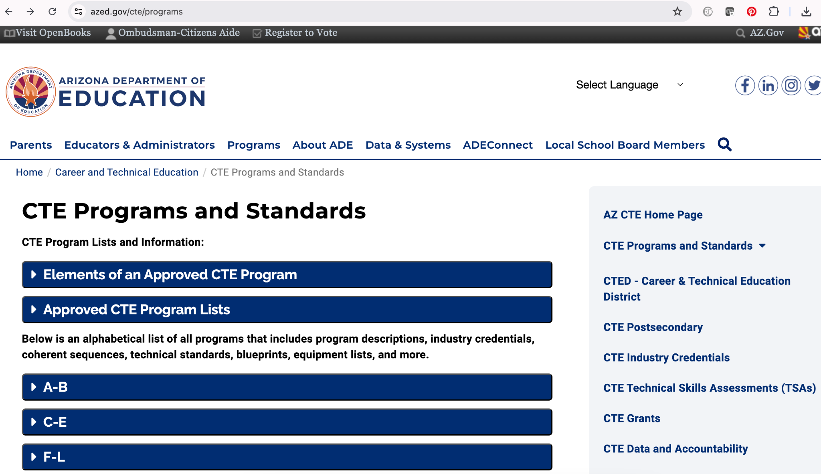



# Step 2: Identify a Community College that Offers the Complementary Occupational Program

Review any existing Intergovernmental Agreement (IGA) between the Community College District and LEA to determine how colleges are assigned to offer classes. Identify the appropriate college within the IGA that offers the complementary occupational program(s).

# Step 3: Review of CTE Curriculum

College faculty with expertise in the occupational program area will review the ADE-CTE curriculum for a specific CTE program and identify clusters of existing community college courses that complement the curriculum: <https://www.azed.gov/cte/programs>

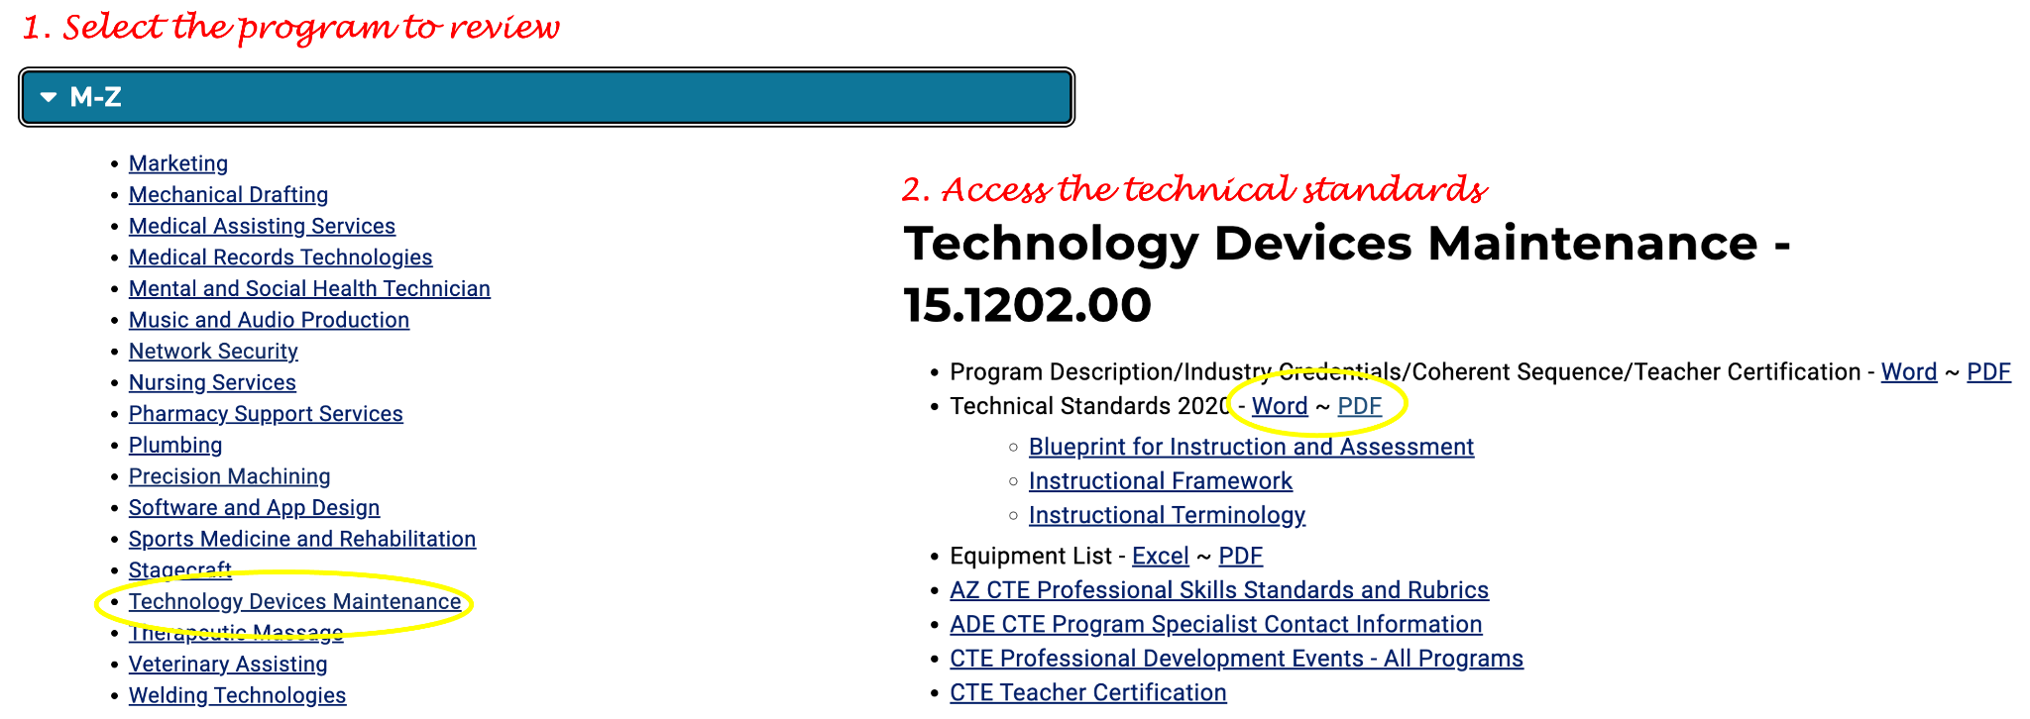

College faculty will also identify the most relevant college program(s) by which the credits apply.

* The college and high school curriculum are not required to be an exact match. If needed, the high school curriculum can be enhanced to integrate all of the required concepts on the college curriculum guide.
* Each ADE-CTE program is offered for 2-3 years on the high school campus. College courses offered on the high school campus during the high school day may be scheduled as a semester-long or year-long course.
* Since high school seat time exceeds college contact hours per course, it is feasible for multiple college courses to complement a single ADE-CTE program.

The table below displays an example of a curriculum review of the ADE-CTE Technology and Device Maintenance program by faculty in the Maricopa County Community College District.

#### Table 1. Example Curriculum Alignment Technology Device Maintenance

| **ADE-CTE Program** | **Complementary College Courses** | **College Program(s)** |
| --- | --- | --- |
| Technology Device Maintenance | 1. CIS105 Survey of Computer Information Systems 2. BPC170 A+ Exam Prep: Computer Hardware Configuration and Support 3. BPC270 A+ Exam Prep: Operating System Configuration and Support | Network and Systems Administration |

# Step 4: Review of Industry Credentials

The ADE-CTE program overview document lists the approved industry credentials that high schools may already integrate into their program. College faculty should review the credentials and identify any of the work-based certificates that are the equivalent to college courses that were identified in Step 2.

The table below displays an example of a review of industry credentials that are approved for an ADE-CTE program and the equivalent credits that the Maricopa County Community College District has approved for each certificate.

#### Table 2. Example Prior Learning Assessment for Industry Credentials in the Technology Device Maintenance Program

| **ADE-CTE Approved Industry Credential** | **Maricopa Colleges Approved Prior Learning Assessment** |
| --- | --- |
| CompTIA+ | BPC170 A+ Exam Prep: Computer Hardware Configuration and Support |
| BPC270 A+ Exam Prep: Operating System Configuration and Support |

Courses approved as prior learning assessment should not be offered for dual enrollment credit. However, it is imperative that students are provided information about the college process to earn prior learning assessment credit. The figures below are examples of marketing tools that were created by Mesa Community College to inform students about the opportunities and process to earn prior learning assessment credit for work-based certificates that may be part of the high school CTE programs.

#### Figure 1. MCC Prior Learning Assessment Opportunities for High School Students

#### 

#### Figure 2. MCC Prior Learning Assessment Process for High School Students

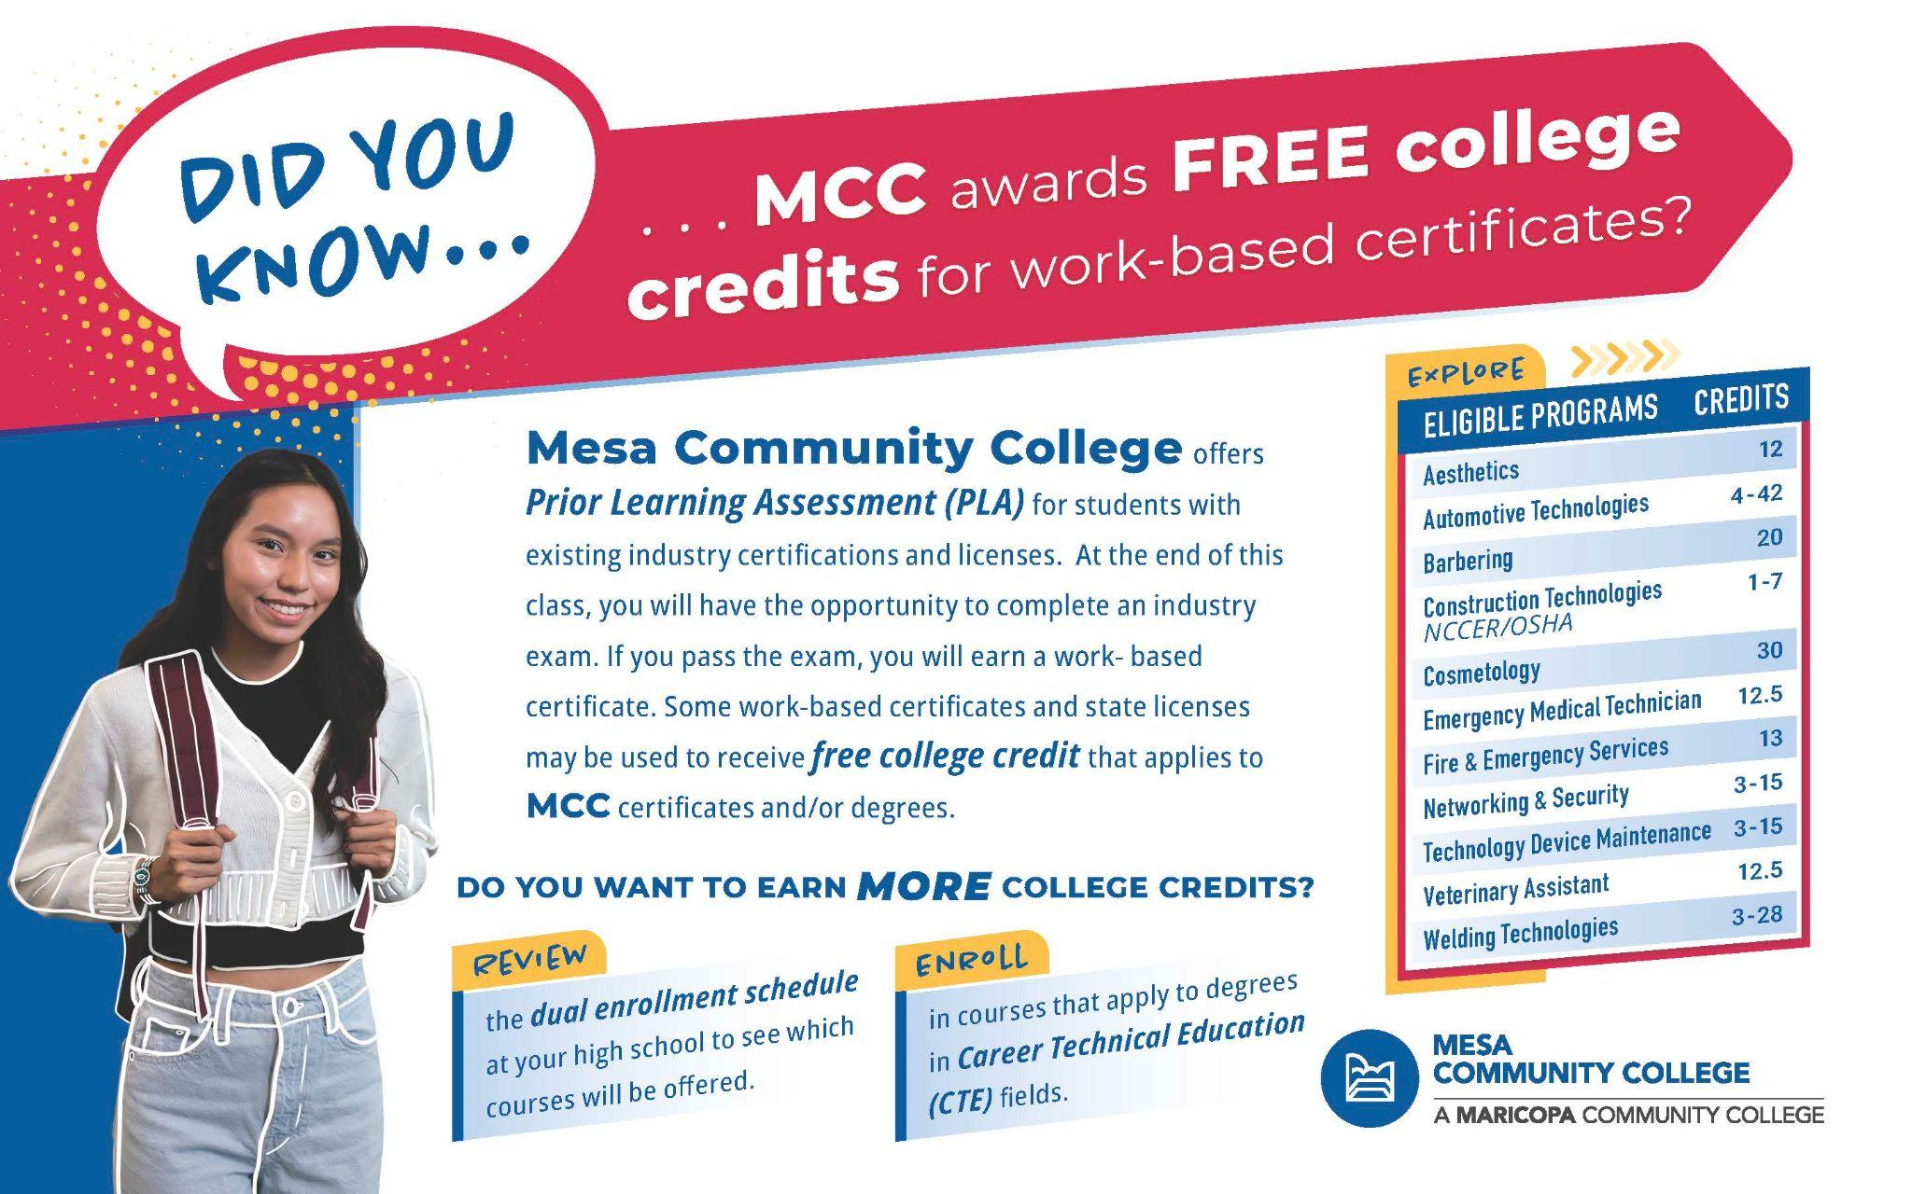

These marketing tools were designed to be printed as the front and back sides of a postcard. Counselors and others may use the front side of the post card to inform students about the opportunities for college credit earned by prior learning assessment of industry credentials also referred to as work-based certificates. The back side of the card may be used by high school teachers, counselors, and others to inform students about the process to earn college credit for work-based certificates.

# Step 5: Develop the Early College Program of Study

An early college program of study for occupational programs demonstrates the high value academic and occupational courses that satisfy high school and college degree requirements. These programs of study are organized to display high school graduation requirements and opportunities for earned college credit.

In addition to displaying occupational courses that complement the high school CTE program and likely satisfy elective requirements, these programs of study display earlier academic courses that are required for a complementary associate’s degree. Usually, these courses include English Composition 1 and 2, the recommended math course, one or more lab science, and one or more social science courses. The academic courses are also referred to as general education curriculum, which is required for any college degree.

The figure below displays a sample early college program of study for students to make progress towards earning an associate’s degree in Technology Device Maintenance or a related field. Maricopa Community College District codes are used as an example based on the information provided in Steps 3 and 4.

#### Figure 3. Early College Program of Study Technology Device Maintenance

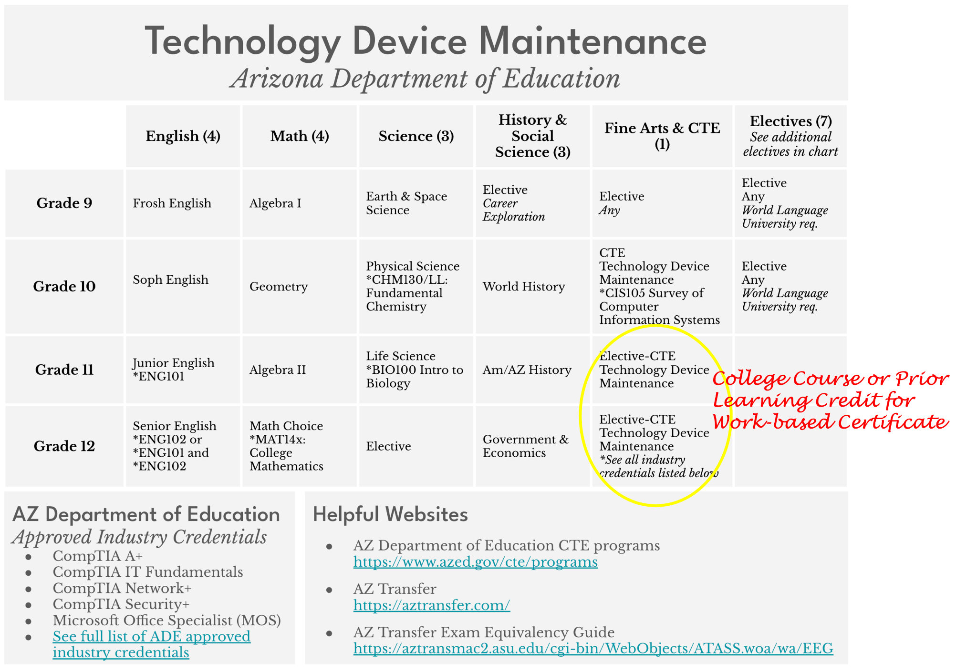

In occupational areas, College Mathematics (or higher) is frequently the only required math course for an associate’s or bachelor’s degree. This means a student can satisfy their college math requirement, if they successfully complete the college course in high school.

As an implementation strategy, the LEA should review student success rates for nationally recognized exams such as Advanced Placement to determine the most appropriate course offering type (e.g. AP and/or dual enrollment) for the core academic courses.

After the program of study is developed, the LEA should employ annual reviews to determine if courses are offered as part of the high school day by a college-qualified high school teacher or if a college instructor teaches the course in-person, online, or in a hybrid format during the high school day. An alternative implementation strategy is student access to earned credit by enrolling into the course on the college campus and matriculating the credit to the high school transcript. Prior approval for college credit applied to the high school transcript is recommended to ensure that all students have access to the same type and amount of credit awarded to the high school degree.

Review the IGA for more details about the requirements to offer a course for dual enrollment credit on the high school campus that is taught by a college-qualified high school teacher.

See the [High School Implementation Annual Timeline](https://docs.google.com/presentation/d/1xEGPpvvfn3n1x0-NjdjPdzHfE3sGPga1pwXSMsIKbFw/edit?usp=sharing) tool for additional strategies for the LEA to increase student access to earned college credit.