# Directions

Use the following sheet to guide you on your Career OneStop Interest Assessment. You will need to use this website to answer the following questions <https://www.careeronestop.org/toolkit/careers/interest-assessment-questions.aspx>.

At the end of the assessment you will be given this information:

Click on the details to see your scores for each interest column. 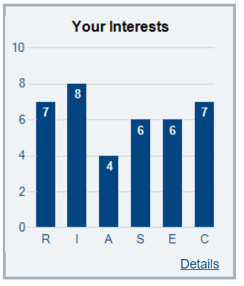

|  |
| --- |
| Realistic people tend to have athletic interests, prefer to work with objects, machines, tools, plants or animals, and like to be outdoors. |
| **At work and at home, you may:**   * Be independent, practical, systematic, self-controlled, and straightforward * Like to work outdoors, be physically active, work on electronic equipment, train animals, and build things * Be able to play a sport, fix things, operate tools and machinery, plant a garden, camp outdoors |
| Your **Realistic** Score: |

|  |
| --- |
| Investigative people like to observe, learn, investigate, analyze, and solve problems. |
| **At work and at home, you may:**   * be logical, curious, thoughtful, observant, and intellectual * like to work independently, explore ideas, analyze data, explain scientific theories, or perform experiments * be able to think abstractly, interpret formulas, use a computer or microscope, or solve complex problems |
| Your **Investigative** Score: |

|  |
| --- |
| Artistic people like to work in unstructured situations using their imagination and creativity. |
| **At work and at home, you may:**   * be creative, imaginative, unconventional, expressive, innovative, and impulsive * like to work on crafts, take photos, attend concerts, art exhibits, and plays, or enjoy reading fiction * be able to sing, play an instrument, act or dance, draw or paint, create designs, or write stories, poetry and music |
| Your **Artistic** Score: |

|  |
| --- |
| Social people like to work with people to inspire, inform, help, train or cure them**.** |
| **At work and at home, you may:**   * be patient, insightful, responsible, cooperative, outgoing, and skilled with words * like to work in groups, volunteer, solve personal problems, or serve your community * be able to teach others, mediate disputes, lead a discussion, communicate well, or plan and supervise activities |
| Your **Social**  Score: |

|  |
| --- |
| Enterprising people like to work with people to influence, persuade and lead them, and to achieve organizational or financial goals. |
| **At work and at home, you may:**   * be assertive, energetic, persuasive, ambitious, or optimistic * like to make decisions, take on leadership roles, meet influential people, or run campaigns * be able to initiate projects, give speeches, persuade or inspire others, lead a large group, or develop organizational goals |
| Your **Enterprising** Score: |

|  |
| --- |
| Conventional people like to work with information, carry out detailed tasks, and have clerical or numerical interests. |
| **At work and at home, you may:**   * be efficient, well-organized, persistent, methodical, or conscientious * like to follow a plan, organize information or materials, work with numbers, use a computer, or collect data * be able to meet deadlines, keep accurate records, file and organize documents, use a database, or work with systems |
| Your **Conventional** Score: |

**List your Top 3 Job Matches**

|  |
| --- |
| **Career Match 1:** |
| **Career Match 2:** |
| **Career Match 3:** |

**Any final thoughts on this assessment. Do you agree or disagree with the results?**