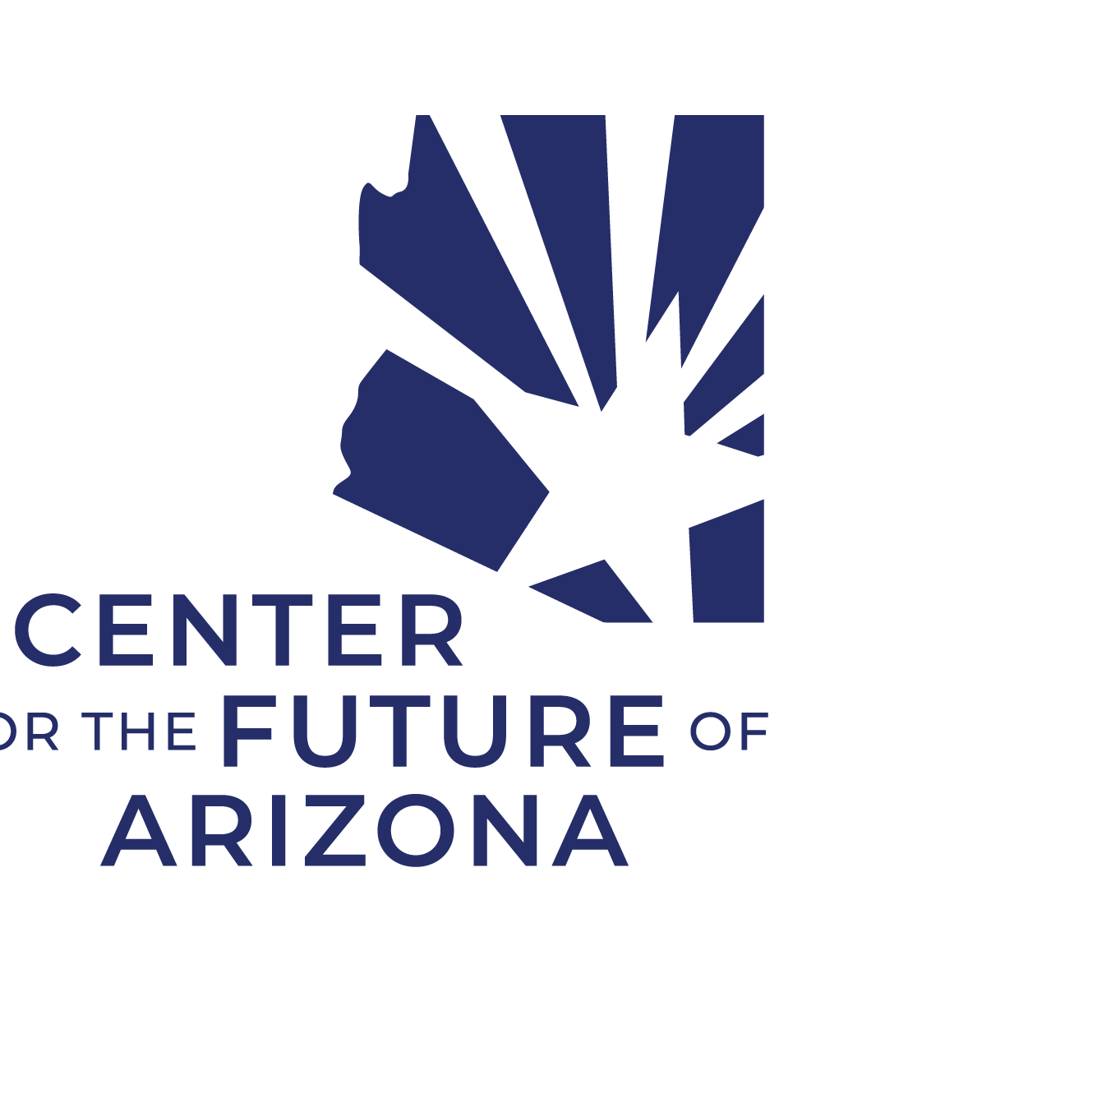 **AT-A-GLANCE - Middle School Career Exploration Strategic Alignment Process**

| **STEP** | **Meeting** | **Participants** | **Meeting Goals and Outcomes** |
| --- | --- | --- | --- |
| **1** | **Planning Session**   * 60-90 min * [Sample Agenda](https://www.arizonafuture.org/media/i0vl3sxe/step-1-district-planning-session-sample-agenda.docx) * Resources:   + [MS Resources Prez](https://www.arizonafuture.org/media/jm5clfmz/career-exploration-resources-edited-rb.pptx)   + [Process Overview](https://www.arizonafuture.org/media/pflfemrp/process-overview.pdf)   + [AT-A-GLANCE](https://www.arizonafuture.org/media/tbdpovam/resources-at-a-glance.docx) | 1. Superintendent and/or Assistant Superintendent 2. District-level “Project Champion” who will serve as a point person and project manager 3. Middle School Principals | * Know who key partners and champions are * Understand various roles and responsibilities * Be able to articulate project goals, 8th grade outcomes, and project timeline |
| **2** | **Partner Overview**   * 60 min * [Sample Agenda](https://www.arizonafuture.org/media/zcuo2nc5/step-2-partner-overview-sample-agenda.docx) * Resources:   + [MS Resources Prez](https://www.arizonafuture.org/media/jm5clfmz/career-exploration-resources-edited-rb.pptx)   + [Process Overview](https://www.arizonafuture.org/media/pflfemrp/process-overview.pdf)   + [Employer Engagement](https://www.arizonafuture.org/media/wncbsq3i/employer-engagement-framework.pdf)   + [Partner Worksheet](https://www.arizonafuture.org/media/clvdr2jj/partner-engagement-worksheet.docx) | 1. External Partners 2. Site-based Partners 3. District Leadership 4. Project Champions | * Know about AZ MS Career Exploration process * Understand various levels of WBL engagement * Be able to identify ways they can support MS students and educators in Career Exploration |
| **3** | **Design Lab**   * 2+ hour (in-person) * [Sample Agenda](https://www.arizonafuture.org/media/oplhcj4c/step-3-design-lab-sample-agenda.docx) * Resources:   + [Process Overview](https://www.arizonafuture.org/media/pflfemrp/process-overview.pdf)   + [Design Lab Activity](https://www.arizonafuture.org/media/nprfycsy/design-lab-activity-sheet.docx)   + [Prototyping Template](https://www.arizonafuture.org/media/1ipdxvkz/prototyping-template.docx)   + [Broadening the Path](https://www.arizonafuture.org/media/trqlaos5/2020-broadening-the-path-report-snapshot.pdf)   + [AZ 5-8 Career Literacy Standards](https://www.arizonafuture.org/media/aqyjhozg/5-8-career-literacy-standards.pdf)   + [Employer Engagement](https://www.arizonafuture.org/media/wncbsq3i/employer-engagement-framework.pdf)   + [5-8 Career Literacy Graphic](https://www.arizonafuture.org/media/hych1h2q/5-8-career-literacy-graphic.pdf),   + [Example District Implementation Plan](https://www.arizonafuture.org/media/hq5blkw2/example-ms-career-exploration-plan.docx) | 1. Middle School Teams 2. Project Champions 3. Site-specific Partners | * Know about MS ECAP and district goals * Understand how MS Career Exploration aligns with stakeholder needs and regional LMI data * Be able to identify campus assets, district resources, partner org relationships to link and leverage for MS Career Exploration |
| **4** | **Resource Demo**   * 60 min - virtual * [Sample Agenda](https://www.arizonafuture.org/media/hpsjo3lo/step-4-resource-demo-sample-agenda.docx) * Resources:   + [Resources DEMO Prez](https://www.arizonafuture.org/media/rkklcvdf/career-exploration-resources-demo-full.pptx)   + [Resource Review Worksheet](https://www.arizonafuture.org/media/rtgmmfau/resource-review-worksheet.docx) | 1. Middle School Teams 2. Project Champions 3. Site-specific Partners 4. Interested MS Staff | * Know more about available Career Exploration resources * Understand how to access and implement resources * Be able to follow up and explore resources on their own time before implementation planning |
| **5** | **Implementation Planning**   * 5-10 hours in-person * [Sample Process](https://www.arizonafuture.org/media/10zfonm2/step-5-implementation-planning-sample-agenda.docx) * Resources:   + [Implementation Planning Guide](https://www.arizonafuture.org/media/aq2axgwt/implementation-planning-design-guide-part-1-2.docx)   + [Could→Should→Will](https://www.arizonafuture.org/media/mfcc04jb/could-should-will-map.docx)   + [Implementation Timeline](https://www.arizonafuture.org/media/de3jhdje/implementation-timeline-template.pptx)   + [Feedback Sheet](https://www.arizonafuture.org/media/ce5pmku4/feedback-sheet.docx) | 1. Middle School Teams 2. Project Champions (as needed) 3. Site Partners (as needed) | * Know your MS Career Exploration goals + BIG ideas * Understand how to begin implementation with existing resources and Partner Org support * Be able to articulate when, where, and how MS Career Exploration will happen Year 1 |
| **6** | **Professional Development**  TBD by site Implementation Plans | 1. Middle School Teams 2. Additional Staff (as needed) 3. Project Champion (as needed) | * Know how to use key resources * Understand how to implement and get support * Be able to access and utilize resources |
| **7** | **Celebration**   * 60-90 min * [Sample Agenda](https://www.arizonafuture.org/media/rimkdfx2/step-7-celebration-and-share-out-sample-agenda.docx) | 1. All Middle School Teams 2. District Leadership 3. Project Champions 4. Partner Orgs | * Know how each school is implementing * Understand how Partner Orgs can plugin * Be able to start identifying WBL collaborations |